**CHAPTER THREE**

**METHODOLOGY**

1. **Design Consideration**

The proposed RFID Smart Card Reader is a software – hardware hybrid, that detects student ID cards as input, sends this input to the server and return a true or false (red or green lights), depending on what operation was done. The hardware consists of:

* Node MCU ESP8266 Microcontroller
* MRC522 RFID Sensor and its Tags
* A Buzzer
* 9V Batteries
* I/O Switch
* LED’s (Red, Green, Yellow, Blue)

The software is a web application hosted on an Apache hosting service built with:

* HTML
* CSS
* PHP
* JavaScript
* MySQL

At the end of development, the hardware should be able to read a student’s ID card, send this info to the server, and get a true or false response.

1. **Summary of Project Methodology**

After coupling all the hardware parts and making sure the Wi-Fi connects successfully, the software/web app should be built and the correct API endpoints setup. The hardware should be able to read a student’s ID card, send this info to the server, the server confirms if he or she has performed a task like paying school fees, paying departmental/faculty fees and returns a true or false reply. The hardware device displays this as either Red(false) or Green(true).

1. **Data Source/Collection**
2. Manual Registration/Entries: The web app is built to allow Staff and Students to register. This includes assignment of individuals to unique ID cards
3. Mockaroo Test Data: Mockaroo is an online service that allows users create mock data, up to 1000 rows, in many formats including: JSON, CSV, SQL and so on.
4. Usage: With every card scan, data is stored. The users name, context of use, date, time and so on.
5. **Hardware Requirements**
6. Power supply of 9 to 12 Volts is recommended for the Node MCU Microcontroller
7. The Wi-Fi hotspot name (SSID) and its password, must be set to what is specified for the device to connect successfully
8. A stable internet connection on the Wi-Fi hotspot enabled device.
9. A working RFID tag
10. Arduino IDE: This is a free and open source Integrated Development Environment(I|DE) used for programming Arduino based microcontrollers and building IoT devices.
11. **Software Requirements**
12. VS Code IDE: This is a free and open source Integrated Development Environment(I|DE) used for programming vast amounts of programming languages through its publicly available extensions.
13. Apache Web Server: This is a free and open source web server that powers a very high percentage of the web. It contains support for multiple programming languages (PHP, Rust) and multiple Database Management Systems (SQL, Postgress)
14. Postman: This is a free and open source tool used for simulating, testing and troubleshooting web API’s
15. Google Chrome: This is a popular web browser created by Google. Used for surfing the web and using our web app.
16. **Block Diagram of Proposed System**

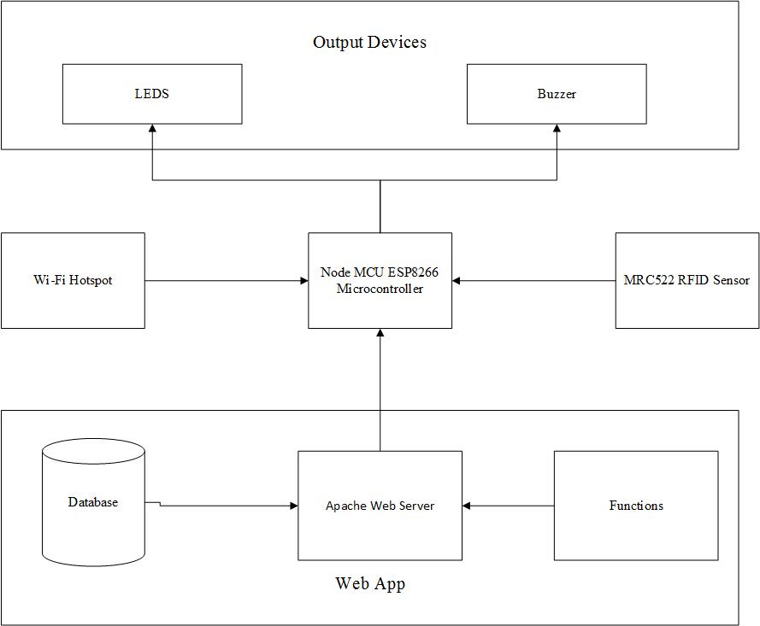

**Fig 5: Block Diagram of Both Hardware and Software Systems**

1. **Software Universal Modelling Language Diagrams**